The Environmental Portfolio – Magaliesberg Archdeaconry
A Position Paper
Co-ordinator: Fr Raynard Schovell
Environmental Chaplain
Diocese of Pretoria
Email: sh.admin@mweb.co.za
Contents
1. MOTION ON CREATION AND THE ENVIRONMENT 2
2. Extract from the Anglican Communion Environmental Network 3
3. The purpose of this document 3
4. The process to be followed 4
5. Suggestions for St Wilfrid’s, Magaliesberg Archdeaconry 5
5.1. Our services 6
5.2. Advocacy 6
5.3. Gardening 7
5.4. Recycling 8
5.5. Stewardship 9
5.6. Cleaning up the environment 9
5.7. Job opportunities 10
6. Monitoring and evaluation 11
7. Ecosystem services 13
8. The Process 16

The following motion was put before the 2017 Synod of the Pretoria diocese: -

MOTION ON CREATION AND THE ENVIRONMENT
The Principle:
WHEREAS our Country has in recent decades suffered the environmental impact of over-consumption, increasing population growth, deforestation, over-fishing, exploitation of non-renewable resources, insurmountable waste dumps, and pollution:
AND WHEREAS we believe that this has been the underlying cause of environmental disasters, acid rain, ozone depletion, climate change, and the extinction of species:
AND Whereas one of the five marks of mission of the Anglican Communion is: "To strive to safeguard the integrity of Creation and sustain and renew life of the earth." And the ACSA Environmental Network, SAFCEI (The Southern African Faith Communities Environment Institute) and other organizations are promoting the application of this through the eco-congregation movement.

The Resolution:
NOW THEREFORE THIS SYNOD RESOLVES THAT:
1. The Diocese of Pretoria through its structures be encouraged to:
- Listen and take note of the sad state of the environment, identify, proclaim and implement measures to protect our God-given resources and to reduce our own carbon footprint.
- Engage with different communities to listen to, discuss with and challenge them regarding their use and abuse the Earth's resources, to foster responsible Earth- Keeping for future generations, appropriate to their circumstances.
2. All Parishes be encouraged to:
- "Reduce, Reuse, Recycle" - both as a Parish and as individuals through the use of paper, glass and plastic recycling bins in Parishes,
- Find ways to save water and electricity
- Develop and use their grounds to benefit the community (e.g. food gardens)
- Study environmental issues, and share ways to be good stewards of God's Creation
- Celebrate the "Seasons of Creation" during the month of June each year and all other
special Environmental Days.

3. That this Synod respectfully requests the Bishop to:
- Facilitate the formation of a Diocesan Environmental Task Team to address the relevant issues
- Encourage every Parish to have an Environmental Portfolio on Council
- Encourage each Parish to pledge one collection during the celebration of Seasons of Creation annually to the ministry of the Department of Environmental Affairs in our Diocese.
Moved By: The Rev. Raynard Schovell
Seconded By: The Rev. Grant Thistlewhite

Extract from the Anglican Communion Environmental Network
A Network for those who care for God’s creation
Anglicans and Episcopalians worldwide have long been concerned with environmental issues. From extreme weather to food shortages all of us are affected. Guided by the fifth Mark of Mission members of the Anglican Communion Environment Network strive to safeguard the integrity of creation and sustain and renew the earth.
Our Aims
- To encourage Anglicans to support sustainable environmental practices as individuals and in the life of their communities.
- To provide information about policies embraced by synods, councils and commissions, especially by the Instruments of Communion
- To support local initiatives by providing information about ideas and best practices developed around the Anglican Communion
- To share information about resources and initiatives that may be of value to Anglicans everywhere
- To provide an opportunity for interested Anglicans to meet both as a formal network, and informally via electronic media

The purpose of this document
The purpose of this document is to identify current activities and opportunities. This will form the basis for the development of specific objectives together with methods for their monitoring and evaluation later in the process.
The next step will be to develop specific objectives which can be measured and monitored, this needs to be done in conjunction with people involved in the Green Anglicans.

The process to be followed
This process is based broadly on the 8 steps in policy development which may be found at https://www.publichealthOntario.ca/en/eRepository/Eight_steps_to_policy_development_2012.pdf
NOTE 1: In terms of the 8 steps document I have used the word ‘Policy’, but plan may be a better descriptor for the scale at which we will be working.
There needs to be a core group who will give comment, criticism and advice on the development of the document.
The eight steps are as follows and I have indicated how these may be addressed for the parish / diocese. I suggest a less rigorous process for the following reasons:
- We are working on an ad hoc basis where volunteers select the issues which they will tackle
- We are working largely at a parish or archdeaconry level.
- Describe the problem
It is accepted that this has been done by various parishes and summarized at the recent 2017 Synod.
- Assess readiness for policy development
The motion and report presented to the recent Synod indicate that there is acceptance of the need for further action.
This document pulls together the current status quo in the form of a position paper. It is intended that this will form the foundation on which the final document will be based.
- Develop goals, objectives and policy options
During this phase clear goals and objectives will be developed.
- Identify decision-makers and influencers
This step has largely been completed at the Synod and within the diocese.
- Build support for the policy
Currently the support base is scattered but is strong in certain parishes. This needs to be broadened.

- Draft / revise the policy
Taking into account the input from I&APs (Interested and Affected Parties) the plan will be drafted.
- Implement the policy
The plan will include implementation strategies. Bearing in mind that we are working with volunteers, activities will be presented as options to be selected by individuals rather than as imperatives.
- Evaluate and monitor the policy
The plan will include methods for evaluating and monitoring the plan.

Suggestions for St Wilfrid’s, Magaliesberg Archdeaconry
NOTE 2: The following is a broad list based on the activities already underway in the Pretoria Diocese as given in the report to the 2017 Synod by Rev Raynard Schovell. To this I have added some additional ideas.
NOTE 3: As we are working with volunteers rather than employees we need to take this into consideration when managing the activities. To this end I have accepted that activities already underway will continue.
Each theme is organised as follows:
- The issue. This provides a background to the theme.
- Current activities. These are taken from Fr. Raynard’s report.
- Opportunities. Some other possibilities which may be explored.
The following themes are discussed: -
- Our services
- Advocacy
- Gardening
- Recycling
- Stewardship
- Cleaning up the environment
- Job opportunities
The following discussions could apply equally to the parish and parishioners.

Our services
The Issue
Do we treat the environment with respect as part of God’s creation? (E. g. Romans 8: 18-21)
We have various seasons through the church year, one of which is the environment. Do we, as a parish / parishioners, take this into our lives throughout the year or do we move onto the next season and forget about the previous one?
Current activities
- We observe the season of creation as set out by the ACSA.
- We observe relevant days, such as St Francis’ day.
Opportunities
- How could we use these times for effective teaching?
- How can we take these concepts into our lives outside of the immediate environs of the church?
- Other dates that could be celebrated e.g. World Water day, World Environment Day
- Alternately – Observe the environment not as a single season but to celebrate specific days as they come up through the year

Advocacy
The Issue
Are people aware of the bigger picture? By this I mean, for instance, do we see the use of electricity – a clean energy source – as pumping greenhouse gas into the environment somewhere else in the country? For instance, the per capita carbon footprint of South Africans is approximately double the world average because of the quality of coal that is used in the coal-fired power stations.
On what do we base our decisions on which energy source to use?
South Africa is a dry country. Our total surface water resource is approximately 50% of the water carried by the Zambezi, the nearest large river. How can we encourage people to look after water quality and to use water more efficiently?
Current activities
- Clergy, as leaders, need to be informed. This is happening through the Green Anglican movement.
- Some parishioners are on a ‘carbon fast’ for a period. By this I mean, for instance, that individuals limit the use of their cars by walking, cycling of simply by careful planning of their activities.
  - This could be offered to parishioners as a way of making an individual contribution to reducing the carbon footprint.
- Grey water recycle provides a way in which used grey water can be used on the garden rather than irrigating the garden with potable water.
  - There is commercially available material which could be made available to parishioners
Opportunities
- There are opportunities for awareness creation through the promotion of knowledge of Ecosystem services. A brief explanation of ecosystem services is included later in the document.
- Promote the “carbon fast for lent”
- There is the opportunity to share positive stories.
- Install Jo-Jo tanks for rainwater harvesting at the church and encourage parishioners do to likewise.
- Advocacy to get people to recognize the value of water. “Water has no substitute”!
- Advocacy to improve the operation of wastewater treatment works,

Gardening
The Issue
Many people have access to somewhere they can grow plants, whether indoor pot plants or gardens. Do we make use of these opportunities?
Current activities
- There is opportunity for food gardens. Mma Tsepo has led the way in food gardening in the areas to the North of central Tshwane. Indoors there are people who, for instance, germinate seeds of certain plants for use in salads as during germination the full food value of the seeds is mobilized.
- People grow flowers / plants for the church as well as their own homes.
- Where space allows, indigenous trees may be planted. The varieties which attract birds or butterflies, for instance, are known and available from nurseries.

Opportunities
- Training. Where space / resources are limited, gardening may be done in containers. Containers need not be expensive, for instance a couple of used car tires can make an effective plant pot.
- Where space is available food could be grown for distribution to those in need. Are there other organisations with which we could form partnerships for this? Or which could offer training?

Recycling
The Issue
We throw away a lot of the stuff that comes into our lives. Much of this goes onto landfill sites and South Africa is running short of sites to be developed as landfills. Many of the products we buy come carefully packaged and in some cases the packaging may contribute substantially to the total cost of the product. What do we do with unused putrescibles (e.g. organic substances which will rot, such as kitchen waste)?
Current activities
The parish and many parishioners are recycling much of what is not needed. The recycling industry is well developed in South Africa. Amongst the ways in which materials are recycled are through the waste pickers who go through peoples’ dustbins to people separating their waste and having it collected by one or other waste recycling company.
Some parishioners maintain active compost heaps for use as a soil conditioner. Our experience – since we started composting our compost heap has got bigger every year as the productivity of our garden has benefitted from the improved soil. No putrescibles are thrown into the bin so our waste generation is reduced and the bin does not develop bad smells.
St Wilfrid’s has bins for plastic, glass etc. Parishioners who are not recycling at home should be encouraged to bring their recyclable material to the church and deposit these in the bins.
For instance: cool drink bottles and T-shirts are made from polyester and it takes 5 – 8 recycled 2 litre bottles to make 1 T-shirt.
Opportunities
- Food that is to be thrown away may either be composted to improve the soil or, in the case of large quantities, may be sold to piggeries, for instance. Legislation does not permit waste food from restaurants to be given to organisations housing the homeless as far as I am aware.
- Choose items which do not have fancy packaging. Fancy packaging may add substantially to the cost of items. The word “Refuse” should be added to "Reduce, Reuse, Recycle".
- Water bottles – encourage the use of those which may be reused and discourage those which need to be thrown away after a single use.
- Paper recycling from offices.
- Styrofoam packaging – either recycle it of don’t accept it.

Stewardship
The Issue
Stewardship of the environment is an ongoing commitment and may require a change in the way that we do things.
Current activities
Within the church we have several stewardship activities. Mainly this is seen as the commitment of parishioners to support the church in various ways. But important also is our commitment to tend the natural and built environments in a sustainable way. This is taught from the pulpit, but is also an important theme through the bible although it is not usually highlighted.
Opportunities
- Teaching on the contribution of the environment to our quality of life. From this should develop an understanding of the importance of a healthy environment.
  - For instance, an improvement in the environment will increase the value to society of the ecosystem services generated.
- Start artists groups as a way to build awareness of environmental issues.
- Promote the adoption of suitable energy-efficient stoves. There are various designs available which use wood and other sources of energy more efficiently. These will need to be tested to see which are suitable for local conditions.

Cleaning up the environment
The Issue
The environment has the capacity to cope with pollution but this capacity is easily exceeded, especially when people are not aware that the capacity is limited and the processes cannot be hurried. Nevertheless, the increasing number of people, combined with the increasing wealth of the population, means that our demand on resources is increasing at a rate with which the environment is not able to cope.
It is necessary to take into account the contribution of ecosystem services (the environment) to our quality of life when making decisions on how our actions may impact the environment.
Pollution takes many forms such as chemicals, plastics, etc. in the air, soil and water. While many of the naturally occurring substances have a place in the order of things, when present in excess they can cause problems (for instance, greenhouse gasses). There are an increasing number of synthetic substances (solid, liquid and gas) which have no natural place in the environment and are often resistant to being broken down. Many of these have been shown to cause disruptions to ecological and human systems.
Current activities
- Picking up litter. This is important not only for the aesthetics but also because litter which does not easily biodegrade will interfere with natural processes. One example is that cattle will eat plastic bags that are lying around. These they can neither digest nor excrete and so the stomach becomes blocked up to the point where they are not able to feed properly and so they starve.
Opportunities
- Each parish could be encouraged to identify specific areas needing to be cleaned up and then attend to these.
- Clearing alien vegetation is a necessary activity in cleaning up the environment. Need training and direction for this.
- Awareness creation of the importance of not littering in the first place.

Job opportunities
The Issue
There are increasing numbers of people who need to make a living. The contribution of the environment to the livelihoods of poor people is not a consideration when someone’s prime concern is to eat today. The environment is able to heal itself but it does need the pressure to be taken off for this to happen.
Therefore, people need other avenues that they can follow to make a living.
Current activities
I am not aware of any current activities within the diocese in this field.

Opportunities
- Tourism. Tourism is a growth industry. There are opportunities in, for instance, guiding at established tourist centres, local guides for bird watching (a big source of nature-based tourism) or on hiking trails.
- We could arrange for talks by the municipal PR people or trainers to show people some of the opportunities of which may not be aware.
- We could arrange for NGOs and others involved in environmental management to give talks in schools.
- Let people know what job opportunities and training is available.
  - One example, the Water Research Commission (WRC) has a free publication called ‘Water @ Work: a career guide’. This details all the opportunities available in the water industry, many of which such as the trades, management, legal etc. are relevant to other industries as well. It gives training opportunities and contacts. It can be ordered (print copy) or downloaded from the WRC web site (http://www.wrc.org.za/) .

Monitoring and evaluation
Monitoring and evaluation (M&E) for the work is specific to each project and needs to be closely integrated to the project if it is to inform the process and if it is to be cost-effective. I recommend that an appropriate M&E plan be developed which will be appropriate to each project.
The DPSIR Framework
The DPSIR (Driver, Pressure, State, Impact, Response) framework is a simple and robust framework which helps the planning of monitoring and intervention activities.
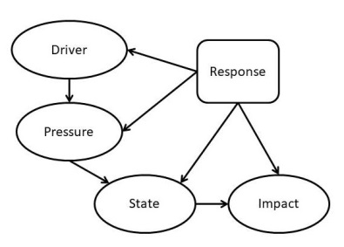
Figure 1: The DPSIR framework
This framework provides a way by which the state or impact seen in the environment may be linked to the driver or pressure causing the state / impact. An example is the pollution of the dams around Gauteng. The driver is the poorly maintained / managed sewage infrastructure. The pressure is the nutrients introduced into the water resource by the sewage overflows. The state is the excessive plant growth in the dams and the impact is the increased cost of subsequent treatment of the water for further use or the danger to human health through recreation activities.
In the example given, monitoring should be aimed at either the state or the impact while the interventions should be aimed at the driver or pressure.
Adaptive management
The process described by Pollard and du Toit (2007) (this site could not be reached when I tried it in November 2017) for the management of the Kruger National Park (illustrated below) provides a rigorous method for developing an integrated adaptive management objectives hierarchy with monitoring feedback loops which inform the success or otherwise of the process.
This process is probably more rigorous than would be required for the parish / archdeaconry but it provides a basis which may be adapted as required.
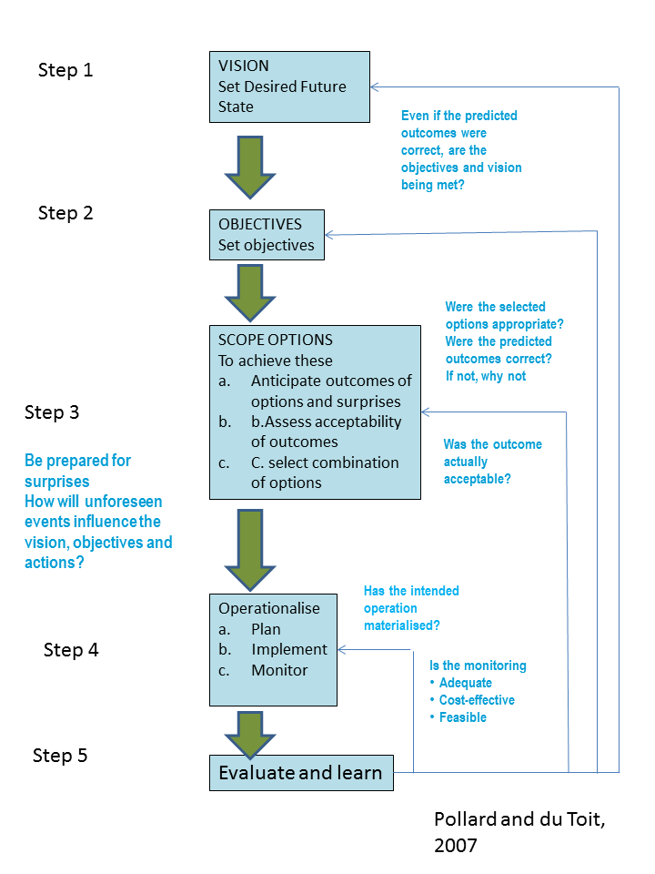
Figure 2: The components of an adaptive management plan.

Ecosystem services
In 1997 Costanza et al. estimated the value of ecosystem services to the global economy annually at between USD 16 to 54 trillion (10¹²) with an average USD33.268 * 10¹². With all the surrounding uncertainties this should be considered a minimum estimate. Most of these services are not traded on the open market and so have no perceived value. At the time this estimate was made the global GNP was about USD18 * 10¹². Although this initial estimate was greeted with disbelief, ongoing research has shown it to be a conservative estimate.
With the increasing awareness of the negative implications of global warming, the recognition that wetlands are important sinks for sequestering carbon has led to research thrust in this area. A recent study found that peatlands in South Africa are important carbon sinks but that the total value of the ecosystem services provided by peatlands, for example, is an order of magnitude (10 times) higher than the value of the carbon sequestered.
The following diagram (from the Southern African Millennium Ecosystem Assessment) illustrates the main categories of ecosystem services and their position in the socio-economic system. While the Provisioning services are the easiest to value, they are, in fact, the least valuable of the four categories. The regulating services provide the ‘insurance policies’ which provide the resilience to recover from extreme events and longer term changes.
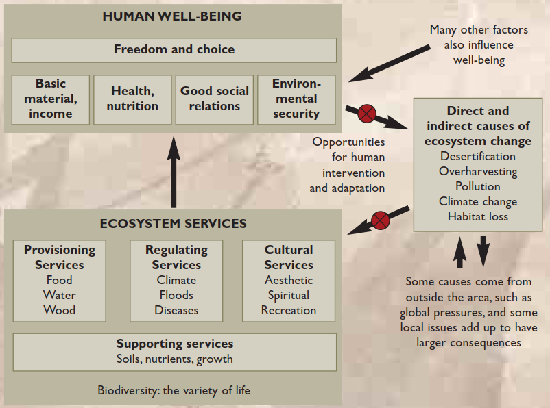
Figure 3: A broad-brush view of the role of ecosystem services in the socio-ecological system (from MEA, 2004).
NOTE 4: The references quoted are available on the internet for download.

The Process

http://acen.anglicancommunion.org/
Kristensen P, 2004. The DPSIR framework. Paper presented at the workshop on vulnerability of water resources to environmental change in Africa. UNEP Headquarters, Nairobi Kenya. 27-29 September 2004.
ftp://ftp.sanparks.org/Kruger/IUCN_Rivers/pollard&dutoit(2005).pdf (this site could not be reached when I tried it in November 2017)
Costanza R, d’Arge R, de Groot R, Farber S, Grasso M, Hannon B, Limburg K, Naeem S, O’Neill R, Paruelo J, Raskin R, Sutton P & van den Belt M, 1997. The value of the world’s ecosystem services and natural capital. Nature 387: 15 May 1997. Pages 253 – 260.
Mulders J, Crafford J and K Harris, 2017, The socio-economic value of peatlands in South Africa. In: Grundling P-L, Grundling AT, Pretorius L, Mulders J & Mitchell S, 2017. South Africa peatlands: ecohydrological characteristics and socio-economic value. Water Research Commission report no. 2346/1/17. Pretoria. 164 pages.
Biggs R, Bohensky E, DesankerPV, Fabricius C, Lynam T, Misselhorn AA, Musvoto C,Mutale M, Reyers B, Scholes RJ, Shikongo S and van Jaarsveld AS, 2004. Nature Supporting People: The Southern African Millennium Ecosystem Assessment. Published by the Council for Scientific and Industrial Research, Pretoria, South Africa. 68 pages.

